Assignment 3 - proposal

RMIT

COSC2657 – Android Development

Team Information

Hoang Phuc – s3879362

Thai Thuan – s3877024

Table of Contents

Application Description 2

Application UI 2

Application Flow 6

Technologies 7

References 8

# **Table of Figures**

Figure 1: Starting Activity 4

Figure 2: View Product Activity 6

Figure 3: Product Detail Activity 6

Figure 4: Backend Flow of E-commercial Application 7

Figure 5: Activity Flow of Application 8

# Application Description

The given requirement asks our group to develop an E-commercial Application. Thus, we decide to build a Sneaker Shopping application which will sell sneakers from a variety of sneakers’ brand such as Adidas, Nike, Puma, … etc. Our group will develop a global application which allow user to access our database from any mobile phone. Because of that, user just need to register an account at the first time they use our application, and all their information will be store in our database. At the next times, they only need to Login to the account and start purchasing our product. Our application’s functionalities will be describing below.

**Application Functionalities**:

There will be two types of account in our application which are manager account and user account. Both will have some common functionalities and separated functionalities. These are detail description about the functionalities of our application.

* **Common Features**: Both manager account and user account can attempt to these features
  + View personal information
  + Change password
* **User features**:
  + Register account
  + View latest product
  + Search by category
  + Search by product’s name
  + Search by product’s brand
  + Add product to shopping cart
  + Select shipping option (pick up or shipping)
  + Wish list (if have time)
* **Manager features**:
  + Get check out announcement from user (later)
  + Manage product (add, update, delete)
  + Manage user shopping cart

# Application UI

The UI sketch is referred from Figma[1]

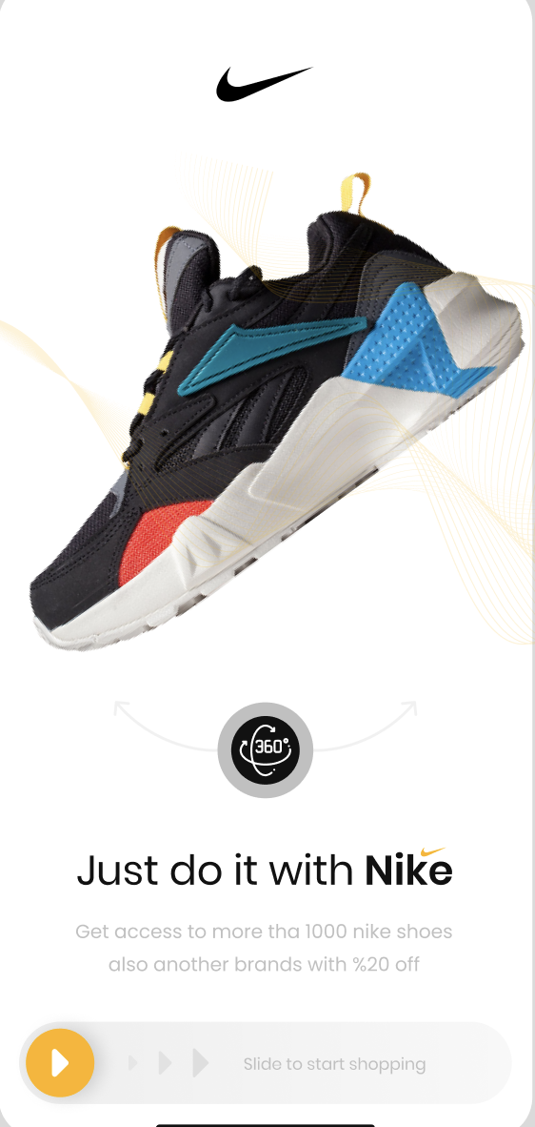

Figure : Starting Activity

To be able to start shopping or searching for products users need to drag the slider from left to right

Figure : View Product Activity

The homepage is the place to display many important information items as well as functions such as search by name, search by brand, suggest trending products, add to cart. In addition, users can view their own profile. Admin has an additional function to receive order information from users.

Figure : Product Detail Activity

When the user clicks on the product, the application will take the user to the detail page about that product. On this page, users can see information about the quantity of each shoe size in stock in the store as well as information about the price for each different size. If the user wants to place an order, just drag the slider at the bottom from left to right, the application will automatically send order information to the admin.

# Application Flow

The application flow is divided into 2 type of diagram which are backend flow and front-end flow. The backend flow illustrates how the application connect to database to retrieve data. In front-end flow, it will describe which activities will appear after user select objects in the application. The detail information about those flows will be shown below.

* **Backend flow:**

The figure describes how we construct the server which allow devices to interact with database through API. Most of services are from Amazon Web Services. We utilize two EC2 instances to run MySQL database and the other will host the Nodejs API

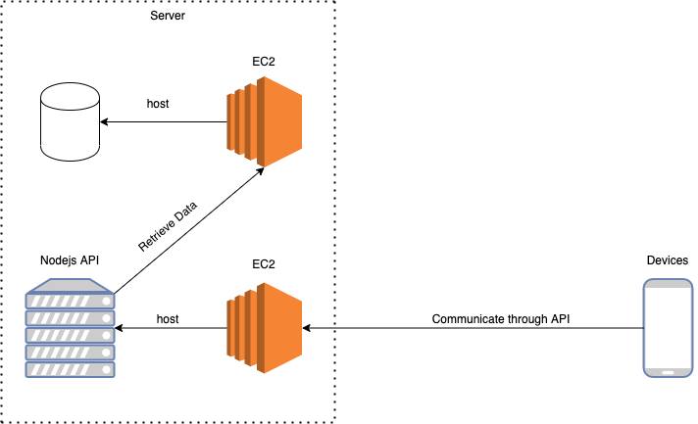

Figure : Backend Flow of E-commercial Application

* **Activity flow**

According to figure, when users start the application, the system will check users’ session firstly to check if they are logging or not. If there is no account signed in, it will load the starting activity for user to choose if they want to create a new account or login to an existed account. If user want to register an account, the application will display a sign-up activity for user to fill in their information. After verifying registered information, it will load the login activity for user to log in. After user enter their account, the system will verify and check the type of account to load the appropriated data and activities.

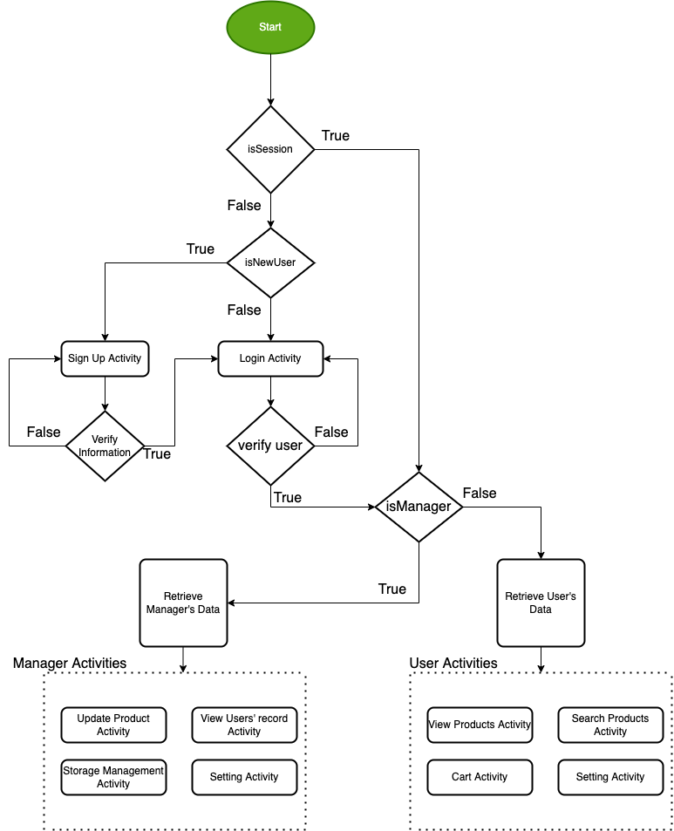

Figure : Activity Flow of Application

# Technologies

For the UI design, we generally plan to utilize Image View to store image of our product and logos also. Some other stuffs such as the information about products and users will be displayed by the Text View. Some functionalities such as allowing user to view product by categories or brands, those categories and brand can be shown in a List View. Especially, according to the UI sketch, we will create a navigation bar at the bottom of the application, so we plan to use Navigation View to perform that feature. However, these are a generally planning about Android Studio components, there should be some changes during the building process.

For back-end stuffs, all the APIs will be developed and host on AWS sever according to figure 4. To retrieve data from server, we will develop some Java methods according to the requirements of that activity to get the data.

# References

|  |  |
| --- | --- |
| [1] | Y. Patel, "E - Commercial App For Shoes," Figma, [Online]. Available: https://www.figma.com/community/file/1177227938968072094. [Accessed 8 December 2022]. |